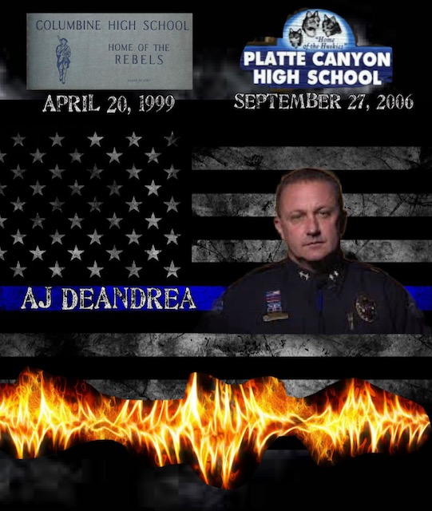
COLUMBINE & PLATTE CANYON
PRESENTED BY:
RETIRED. DEPUTY CHIEF AJ DEANDREA
Wednesday, November 15, 2023 from 8: ooam-5:00pm
Rialto Theatre, Joliet Illinois.
Cost to attend: $150.00 per attendee.

When it comes to preparing your schools for the unthinkable, there is no better training than this one!

N&F Training Solutions believes it is very important to have EVERYONE involved on these critical incidents that have been, and will continue to happen around the country. That is why we have opened an opportunity for our school administrators, and school decision makers to attend this one-of-a-kind training with AJ DeAndrea.
From 8:00am-12:00pm, You will have the opportunity to hear first-hand from AJ what happened at Columbine High School, April 20, 1999. AJ discusses his story of being one of the first operators to enter the high school that day. AJ, gives a powerful and emotional play-by-play of his day inside the school that eventually led him to the library where the shooters were located. AJ, also talks about the positive and negative take away from that day and how active shooter training has evolved since Columbine. AJ also talks about how not just training for law enforcement and public safety have evolved but how school active shooter training has changed as well.
From 12:00pm-1:15pm we will have a lunch break.
From 1:15-5:00pm, you will hear one of the most powerful and emotional debriefs in the country related to school shooting incidents. AJ again will walk you through his day of arriving at Platte Canyon High School September 27, 2006. AJ, who had a different role at Platte Canyon then he did at the Columbine incident. During Platte Canyon he was a team leader for the Jefferson County Sheriff’s Office, Special Weapons and Tactics (SWAT) team. This first-hand presentation of this day will be mind, and life changing for you. It will make you re-think and re-evaluate the things that you do in life and as a school administrator.
Cost to attend this training day is $150.00 per attendee. Payment can be made by:

- check: Checks can be made out to: “N&F Training Solutions LLC” mailed to 1023 Wolf Creek Road, Farmington, Missouri, 63640.

- PayPal: JasonFitzwater@NFTraining.

- Venmo: JasonFitzwater@NFTraining

Or you can also pay on the website with credit card $175.00 (www.nftraining.org 2023 Conference Joliet)

Invoice and tax ID can be provided upon request:

Registration forms need to either be mailed in with payment or emailed to fitzwater0912@gmail.com Registration forms can be sent in without payment also to reserve your seat. We will accept registrations all the way to November 12th. Refunds will be given if requested before October 1st, 2023. No refunds will be given after October 1^{st,} but we will give department credit towards another N&F Training or Conference.

Attendee Name: _____________________________________________________________________
Name of School or District: ______________________________________________________________
Position with School or District: __________________________________________________________
Phone number where you can be contacted: ________________________________________________
E-mail where you can be contacted: _______________________________________________________

Thank you for being part of our conference, and we look forward to having you there with us. Please feel free to check out the rest of the conference at our website www.nftraining.org. We will have a registration table open at the Rialto Wednesday morning beginning at 7:00am. You will be given a ID that will have to be worn to get into the theater. If you are interested in attending the whole conference you can call Jason Fitzwater at 314-920-3930 or his email listed above in the flyer.

